**Assignment 10**

**Task 1. In the Films table create a calculated column called NumberBreaks which shows for each film the number of breaks needed.**

We can create calculated column using IF and SWITCH statement.Following calculated columns were created.

NumberBreaks = if(Films[RunTimeMinutes]>=0 && Films[RunTimeMinutes]<=90,0,

IF(Films[RunTimeMinutes]>=91 && Films[RunTimeMinutes]<=150,1,

IF(Films[RunTimeMinutes]>=151 && Films[RunTimeMinutes]<=210,2,

IF(Films[RunTimeMinutes]>=211 && Films[RunTimeMinutes]<=300,3,

IF(Films[RunTimeMinutes]>=301 && Films[RunTimeMinutes]<=999,4,BLANK())))))

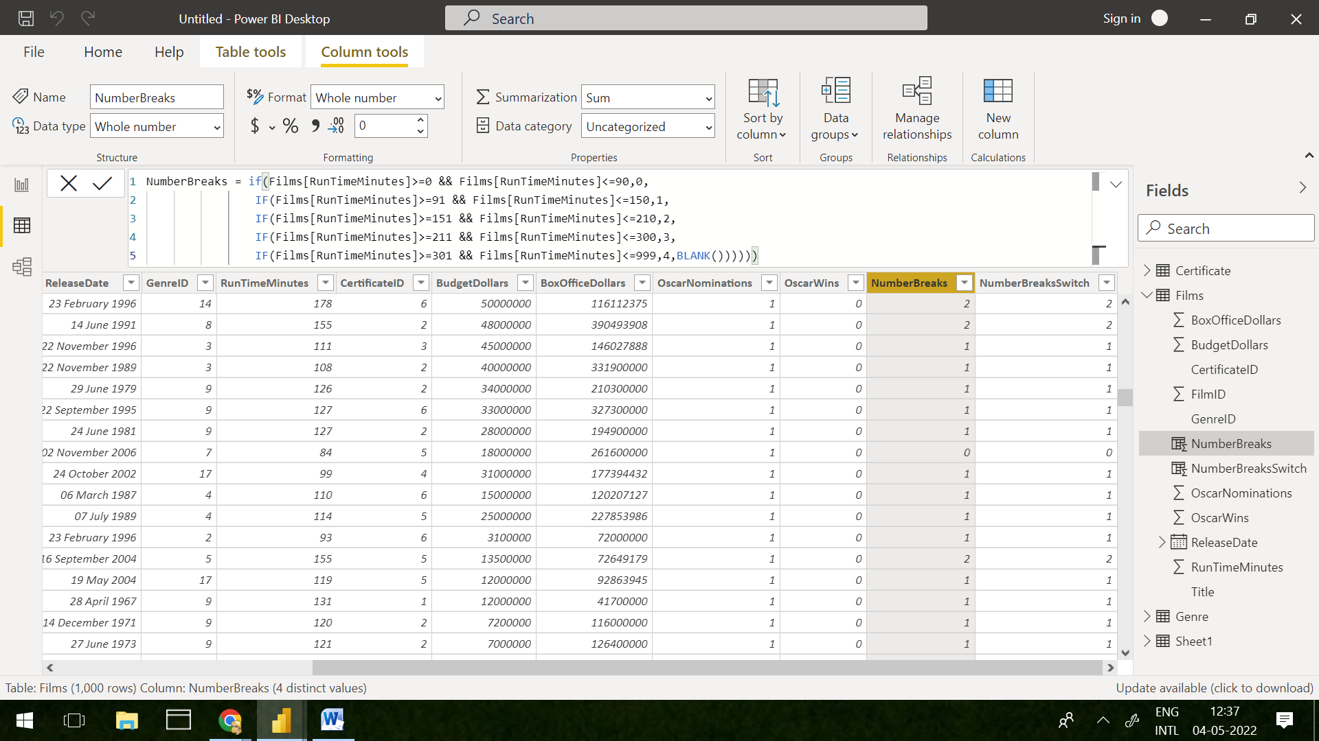

NumberBreaksSwitch = SWITCH(TRUE(),Films[RunTimeMinutes]>=0 && Films[RunTimeMinutes]<=90,0,Films[RunTimeMinutes]>=91 && Films[RunTimeMinutes]<=150,1,Films[RunTimeMinutes]>=151 && Films[RunTimeMinutes]<=210, 2,Films[RunTimeMinutes]>=211 && Films[RunTimeMinutes]<=300,3,Films[RunTimeMinutes]>=301 && Films[RunTimeMinutes]<=999,4,BLANK())

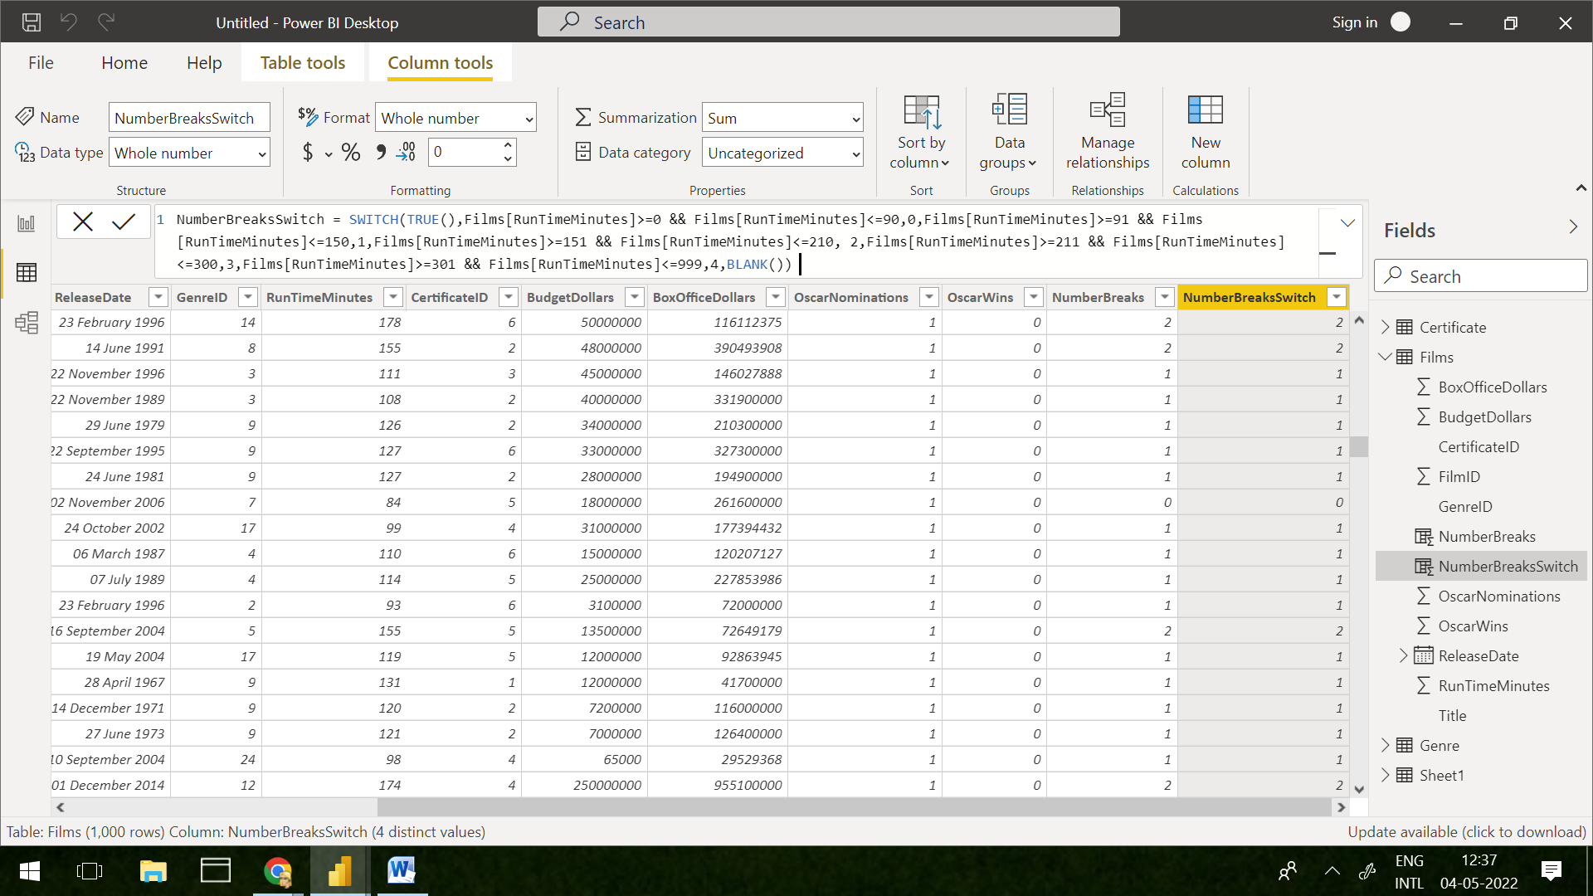

**Final Matrix Output**

